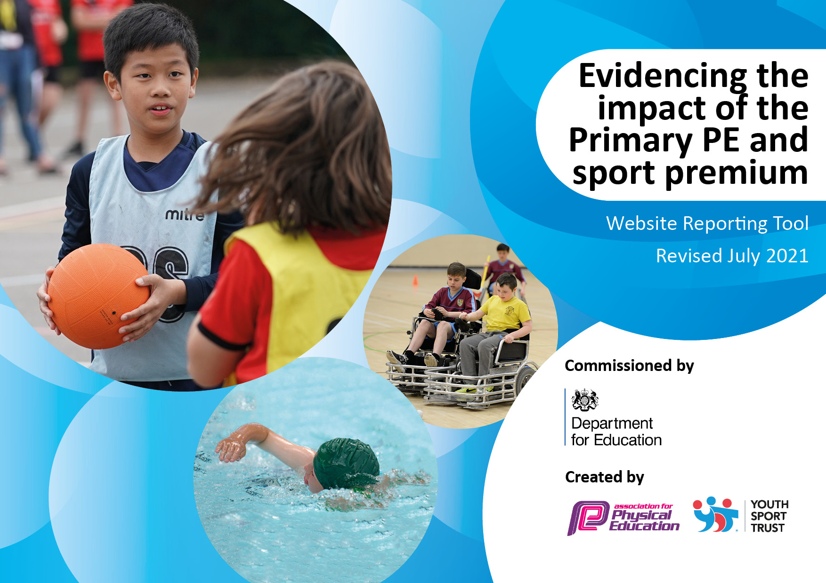
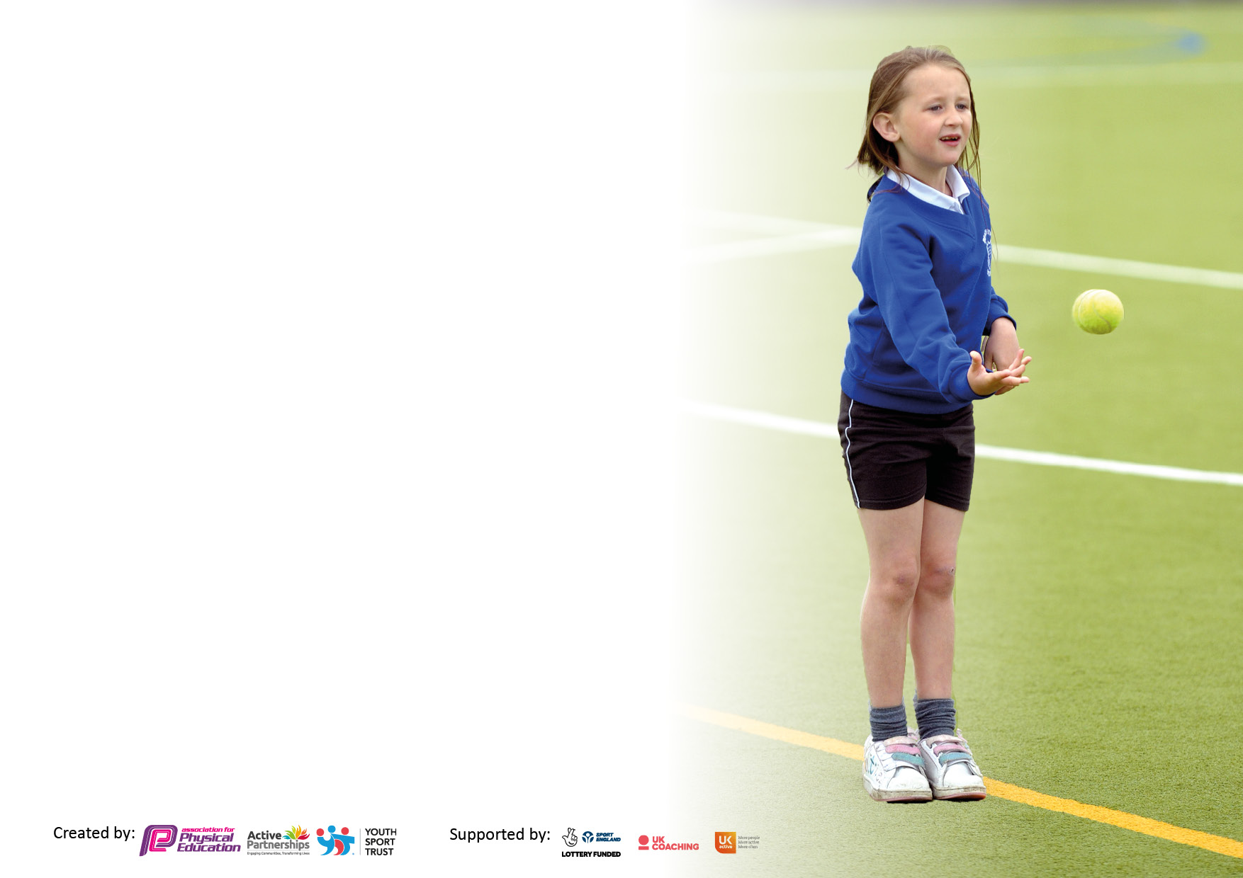

It is important that your grant is used effectively and based on school need. The Education Inspection Framework makes clear there will be a focus on ‘whether leaders and those responsible for governors all understand their respective roles and perform these in a way that enhances the effectiveness of the school’.

Under the Quality of Education Ofsted inspectors consider:
Intent - Curriculum design, coverage and appropriateness
Implementation - Curriculum delivery, Teaching (pedagogy) and Assessment
Impact - Attainment and progress

To assist schools with common transferable language this template has been developed to utilise the same three headings which should make your plans easily transferable between working documents.

Schools must use the funding to make additional and sustainable improvements to the quality of Physical Education, School Sport and Physical Activity (PESSPA) they offer. This means that you should use the Primary PE and sport premium to:

- Develop or add to the PESSPA activities that your school already offer
- Build capacity and capability within the school to ensure that improvements made now will benefit pupils joining the school in future years
- The Primary PE and sport premium should not be used to fund capital spend projects; the school’s budget should fund these.

Please visit gov.uk for the revised DfE guidance including the 5 key indicators across which schools should demonstrate an improvement. This document will help you to review your provision and to report your spend. DfE encourages schools to use this template as an effective way of meeting the reporting requirements of the Primary PE and sport premium.

We recommend you start by reflecting on the impact of current provision and reviewing the previous spend.

Schools are required to publish details of how they spend this funding, including any under-spend from 2019/2020, as well as on the impact it has on pupils’ PE and sport participation and attainment. All funding must be spent by 31st July 2022.

We recommend regularly updating the table and publishing it on your website throughout the year. This evidences your ongoing self-evaluation of how you are using the funding to secure maximum, sustainable impact. Final copy must be posted on your website by the end of the academic year and no later than the 31st July 2021. To see an example of how to complete the table please click HERE.

Details with regard to funding
Please complete the table below.

Total amount carried over from 2020/21 | £7814
Total amount allocated for 2021/22 | £24,400
How much (if any) do you intend to carry over from this total fund into 2022/23 | £5214
Total amount allocated for 2022/23 | £16586
Total amount of funding for 2022/23. To be spent and reported on by 31st July 2023. | £21800
Swimming Data - Please report on your Swimming Data below.

Meeting national curriculum requirements for swimming and water safety.  N.B. Complete this section to your best ability. For example you might have practised safe self-rescue techniques on dry land which you can then transfer to the pool when school swimming restarts.  Due to exceptional circumstances priority should be given to ensuring that pupils can perform safe self rescue even if they do not fully meet the first two requirements of the NC programme of study | Swimming took place with the year 5 and 6 class during the Autumn term 2021.
What percentage of your current Year 6 cohort swim competently, confidently and proficiently over a distance of at least 25 metres?  N.B. Even though your pupils may swim in another year please report on their attainment on leaving primary school at the end of the summer term 2020.  Please see note above | 100%
What percentage of your current Year 6 cohort use a range of strokes effectively [for example, front crawl, backstroke and breaststroke]?  Please see note above | 100%
What percentage of your current Year 6 cohort perform safe self-rescue in different water-based situations? | 100%
Schools can choose to use the Primary PE and sport premium to provide additional provision for swimming but this must be for activity over and above the national curriculum requirements. Have you used it in this way? | We haven’t provided any additional swimming provision this year.

Action Plan and Budget Tracking
Capture your intended annual spend against the 5 key indicators. Clarify the success criteria and evidence of impact that you intend to measure to evaluate for pupils today and for the future.

Academic Year: 2021/22 |  | Date Updated: July 2022
Key indicator 1: The engagement of all pupils in regular physical activity – Chief Medical Officers guidelines recommend that primary school pupils undertake at least 30 minutes of physical activity a day in school
Intent | Implementation |  | Impact
Your school focus should be clear what you want the pupils to know and be able to do and about  what they need to learn and to  consolidate through practice: | Make sure your actions to achieve are linked to your intentions: | Funding allocated: | Evidence of impact: what do pupils now know and what can they now do? What has changed?: | Sustainability and suggested next steps:
All pupils to undertake physical activity for at least 30 minutes per day.  All pupils to engage in at least two hours of PE each week.  Year 5 and 6 pupils to undertake swimming lessons during the Autumn term. | All pupils will engage in physical activity every day between 12:30 and 13:00. Activities and equipment to be made available to pupils. Headteacher to be available at lunchtimes to support pupils and staff on duty and to have equipment available to engage and motivate pupils in physical activity.  Young Leaders to play an active role in supporting younger children to engage in physical activity at break and lunch times.  Pupils in Key Stage One and Two to do PE for 2 hours per week with children in EYFS undertaking one hour of formal PE followed by a range of physical activities organised in addition to their PE lesson. Headteacher to lead PE.  This will ensure that all lessons are of a high quality through regular monitoring.  Coach travel arranged for a six week period to enable lessons to take place. TA provided as additional support for class. | £1170  N/A  £2100 | Pupils engage in physical activity on a daily basis. Staff on duty encourage pupils to be active.  Young Leaders are able to develop their leadership skills.  Pupils are able to progress in terms of the skills and knowledge they learn aligned with the national curriculum requirements.  100% of pupils in year 5/6 able to swim 25 metres. | Teaching Assistants to run lunchtime clubs confidently during the 2022/23 academic year without support from the headteacher.  To employ Sports Activiators to run lunchtime clubs once a week during the Autumn and Spring term 2022-23.  To develop the quality of PE provision through the introduction of gymnastics specialists in 2022/23.  To train two additional staff to lead swimming during the 2022-23 academic year.
Key indicator 2: The profile of PESSPA being raised across the school as a tool for whole school improvement

Intent | Implementation |  | Impact
Your school focus should be clear what you want the pupils to know and be able to do and about  what they need to learn and to  consolidate through practice: | Make sure your actions to achieve are linked to your intentions: | Funding allocated: | Evidence of impact: what do pupils now know and what can they now do? What has changed?: | Sustainability and suggested next steps:
To develop and enhance the resources used for the teaching of PE. | School to upgrade and improve resources to enable a higher quality of PE delivery. | £500 | Pupils make improved progress in PE. All pupils actively engaged in PE lessons during the 2021/22 academic year. | The School Business Manager to look out for grants in 2022/23 to improve the outdoor area and playing surface.
To raise the profile of inter-house sporting competitions. | To purchase stickers and medals for sports day. | £56.87 | Children will be inspired to do their best and learn new skills and disciplines. | To continue with this into the next academic year.
To raise the profile of inter-house sporting competitions. | Suzanne Kirkwood from the Cooper School to lead termly house sporting competitons involving all pupils. | Part of the NOSSP membership  £2200 | All children develop their team work skills and have the chance to represent their house.  Develops competitive sport in a friendly way. | To continue with whole school house events during the 2022/23 academic year.  To set up more inter-school competitons to further raise the profile in 2022-23.

Key indicator 3: Increased confidence, knowledge and skills of all staff in teaching PE and sport

Intent | Implementation |  | Impact
Your school focus should be clear | Make sure your actions to | Funding | Evidence of impact: what do | Sustainability and suggested
what you want the pupils to know | achieve are linked to your | allocated: | pupils now know and what | next steps:
and be able to do and about | intentions: |  | can they now do? What has
what they need to learn and to |  |  | changed?:
consolidate through practice:
To develop teacher’s skills and confidence in the delivery of PE. | Rachel Tucker, tennis coach employed to lead tennis sessions during the Summer term supporting teachers in the delivery of this area.  Suzanne Kirkwood to support school in leading house competions and Sports Day.  Primary PE Planning purchased to provide teachers with planning resources.  HT to lead PE and to observe teaching of PE across the school. | £509  £2200  (NOSSP Partnership)  £395 | Teachers are more confident in delivery of tennis lessons. Pupils have enhanced their ball skills and hand to eye co-ordination.  Teachers and teaching assistants taught a range of skills and activities to promote and develop pupil fitness.  Primary PE Planning provides teachers with a range of lesson plans and resources to develop the quality of PE delivery.  Teachers are supported and upskilled in the delivery of PE. | Rachel to be employed again in 2022/23 to deliver lessons working alongside all teachers.  Teaching assistants to be more involved in leading sporting activities during the 2022/23 academic year at lunchtimes.  To purchase ‘Complete PE’ ready for September 2022 as the new whole school PE scheme.  To employ the services of Stuart Wells to support in the teaching of PE during the 2022-23.
Key indicator 4: Broader experience of a range of sports and activities offered to all pupils

Intent | Implementation |  | Impact
Your school focus should be clear | Make sure your actions to | Funding | Evidence of impact: what do | Sustainability and suggested
what you want the pupils to know | achieve are linked to your | allocated: | pupils now know and what | next steps:
and be able to do and about | intentions: |  | can they now do? What has
what they need to learn and to |  |  | changed?:
consolidate through practice:
To promote and develop pupil’s enthusiasm for sport. | Headteacher to set up and establish whole school house events involving all pupils. Activities to focus on developing pupils self-esteem and confidence.  Suzanne Kirkwood to support the school in leading these events. | £2200  (NOSSP as above) | All pupils are engaged in physical activity and develop their confidence and sense of worth through representing their house at all levels. | To develop and introduce more inter-school competitions in 2022-23 competing in a range of different sports.  To develop the range of after school activities available for all pupils from September 2022.
To develop pupil’s leadership skills through Young Leaders | The school has Young Leaders who support and work with younger children to get them more involved in sport.  The Young Leaders lead lunch and breaktime sessions developing their leadership and communication skills.  This is led by a teaching assistant who organises and runs the sessions. | N/A | Children have the opportunity to develop their leadership skills.  Younger children become more active at break and lunchtimes.  Develops a whole school team spirit and sense of community through active participation amongst all year groups. | To develop the Young Leader role more in 2022/23 so they are more confident in leading sessions without as much adult support.

Key indicator 5: Increased participation in competitive sport

Intent | Implementation |  | Impact
Your school focus should be clear | Make sure your actions to | Funding | Evidence of impact: what do | Sustainability and suggested
what you want the pupils to know | achieve are linked to your | allocated: | pupils now know and what | next steps:
and be able to do and about | intentions: |  | can they now do? What has
what they need to learn and to |  |  | changed?:
consolidate through practice:
To engage in competitive sport to develop pupil’s confidence and skill in match situations. | Suzanne Kirkwood to lead inter-house and inter-class competitions at Charlton.  Suzanne to organise Sports Day with pupils competing against one another.  To up-skill staff in leading inter-house competitions.  To involve sports leaders from the Cooper school to lead different stations at Sports Day.  To utilise the role of young leaders to promote competitive sport amongst the younger classes. | £2200 (NOSSP as above) | All classes compete in competitive house competitions.  Pupils able to apply skills learnt to a match scenario.  Pupils take part in a new style sports day where all pupils were involved at all times.  Staff developed their practice through learning and working alongside Suzanne.  Pupils in all year groups are engaged in competitive sport. | To arrange more inter-school competitons in 2022-23 now the risk of Covid is less.

Signed off by
Head Teacher:
Date: | 30.07.2022
Subject Leader: | Ross Griffin (Headteacher)
Date: | 30.07.2022

